**Expected Income by Gender and Education**

**Introduction**

It is believed that, in general, men have higher salaries than women. There are, however, factors that can be attributed to this belief. Education plays a big role in a person’s salary, regardless of gender. Overall, people with higher education tend to have higher salaries. In this report, we will see if education and gender have a significant effect on income.

**Methodology**

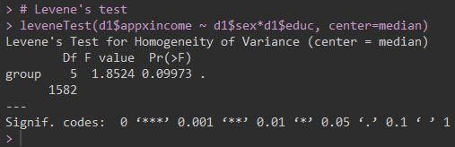We began our analysis by exploring our data. We noticed that there were many missing values. So, we removed those cells from our data frame. We started with 2002 observations but after removing all the missing values we had 1588. Then, we created subsets of our data. We separated our data by gender and level of education to find the average income of each group. We used those averages to find the confidence intervals that we will use later when we plot our data.

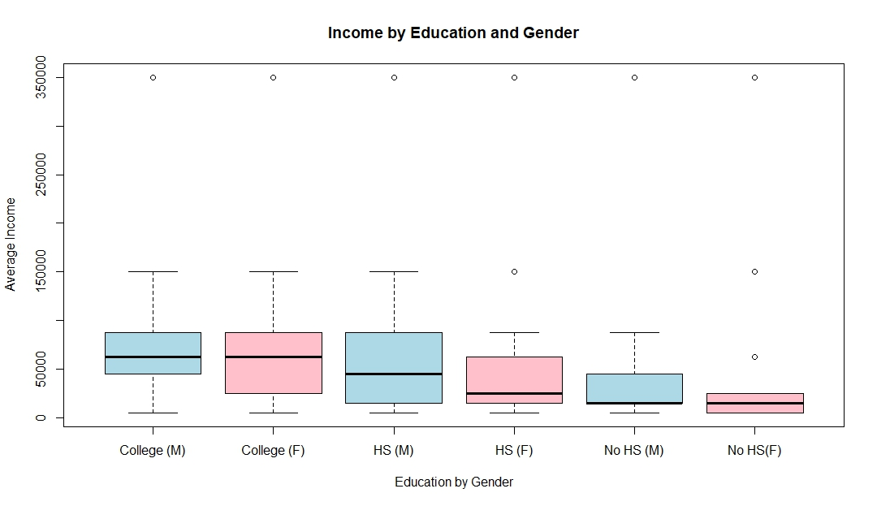To test the assumption of homoscedasticity, we conducted a Levine’s test (figure 1). After, we created a boxplot of the groups, we noticed that there were some outliers but we concluded that they were important for our analysis to be as accurate as possible. Then, we performed our ANOVA, producing the results shown in figure 3.

**Figure 1.** Our Levine's test' p-value is high enough to assume homoscedasticity.

**Figure 2.** There are some outliers, but we did not remove them because there are multiple observations with the same value in all the groups.

**Results**

**ANOVA**

$$H_{O1}:Gender has no significant effect on income$$

$H_{O2}:Education has no significant effect on income$

$$H_{O3}:There is no significant interaction effect between gender and education on income$$

**α = 0.05**

**Figure 2.**  ANOVA

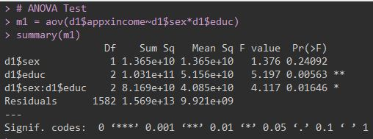

**Figure 3.** ANOVA

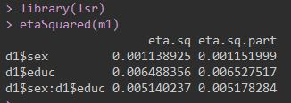**ETA-Squared**

**Figure 4.** **ETA-Squared**.

The effect size for “Gender” is small.

The effect size for “Education” is small.

*The effect size for the interaction between “Gender” and “education” is small.*

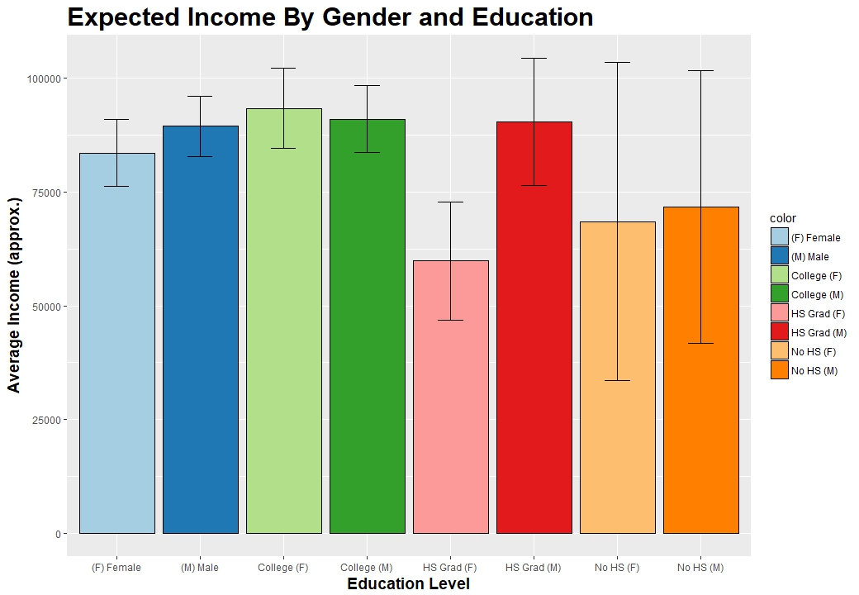**Conclusion**

**Figure 5.** Average income by gender and education with a 95% confidence interval.

At an alpha level of 0.05, we fail to reject the first null hypothesis, gender has no significant effect on income. However, we reject the other two hypotheses. Education has a significant effect on income, regardless of gender. Also, there is a significant interaction effect between gender and education on income.

Based on our bar graph, men with a high school diploma earn, on average, more than their female counterparts. Both, men and women, without high school diplomas earn about the same. At the college level, women generate a higher income than men, but not by much.

Our effect sizes are small for all variables. On average, less than 1% of our variances are accounted by gender, education, or both combined. Although not necessary, if would have improved the accuracy of our analysis if the group sizes were of similar size. Also, about 25% of our data contained missing values, perhaps our group sizes would have been more evenly sized if those values had been used.